Lab 3

P1: Write a program to add an array of eight 2-digit hexadecimal numbers stored in memory and store the result in memory.

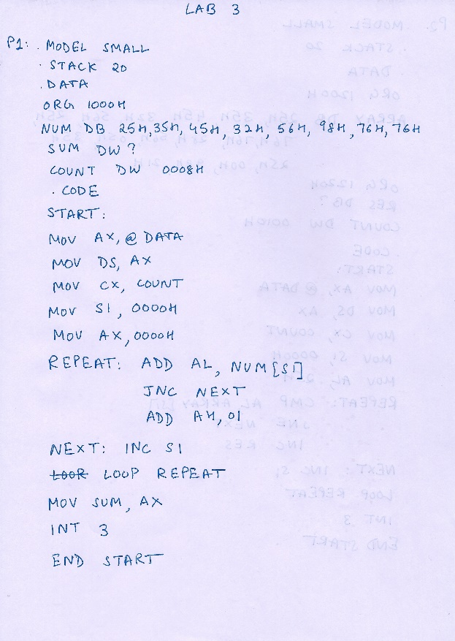

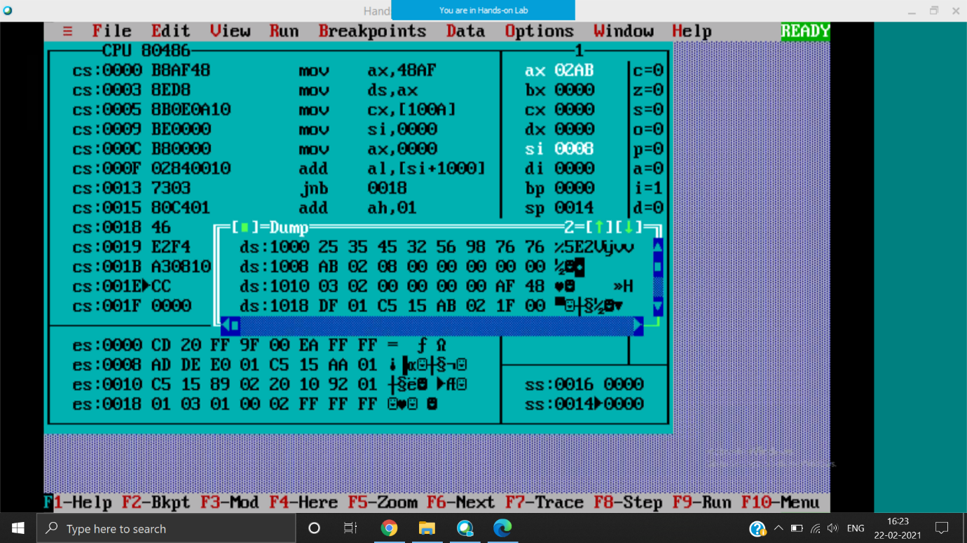

DS: 1000H

Output at 1008, 02AB (ie the sum of the numbers in array)

P2: Write a program to count number of occurrences of the byte 25H in the given array of 16-bytes stored starting from 1200H. Also store the result in 1220H memory location.

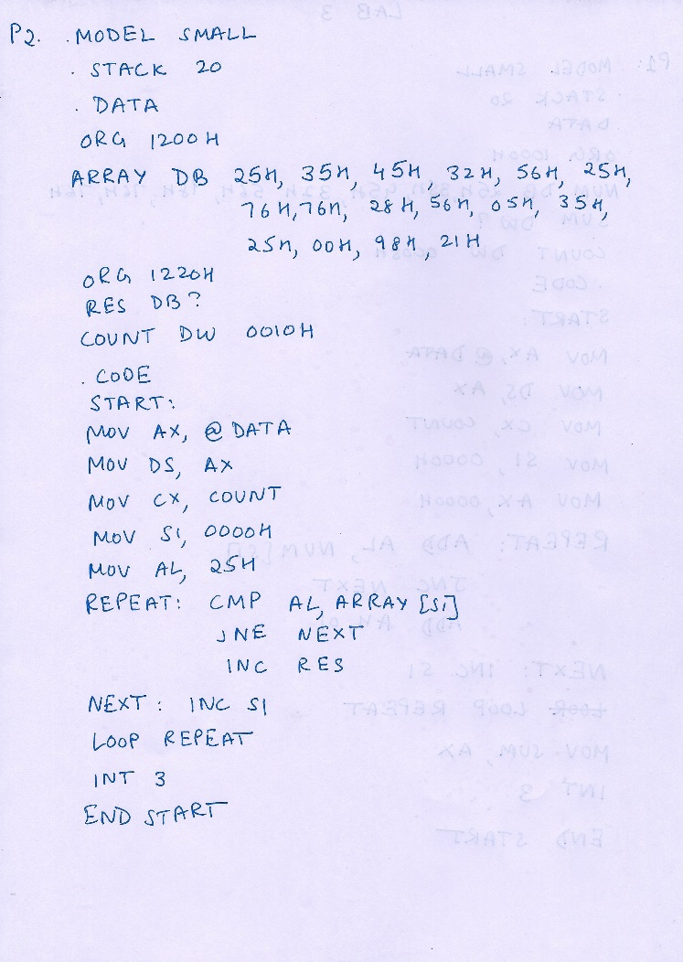

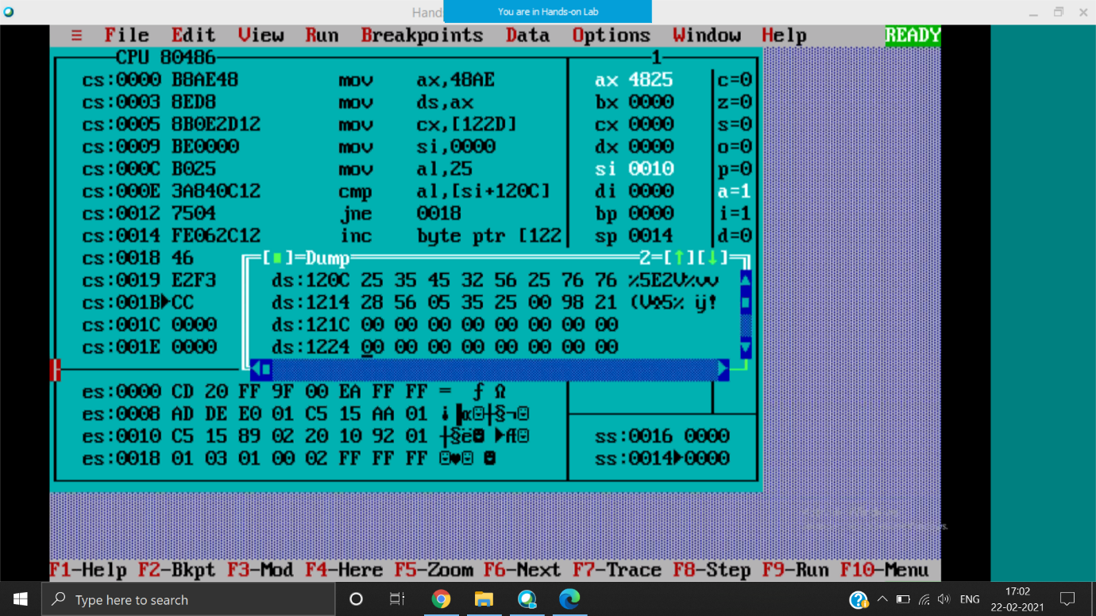

DS:120C

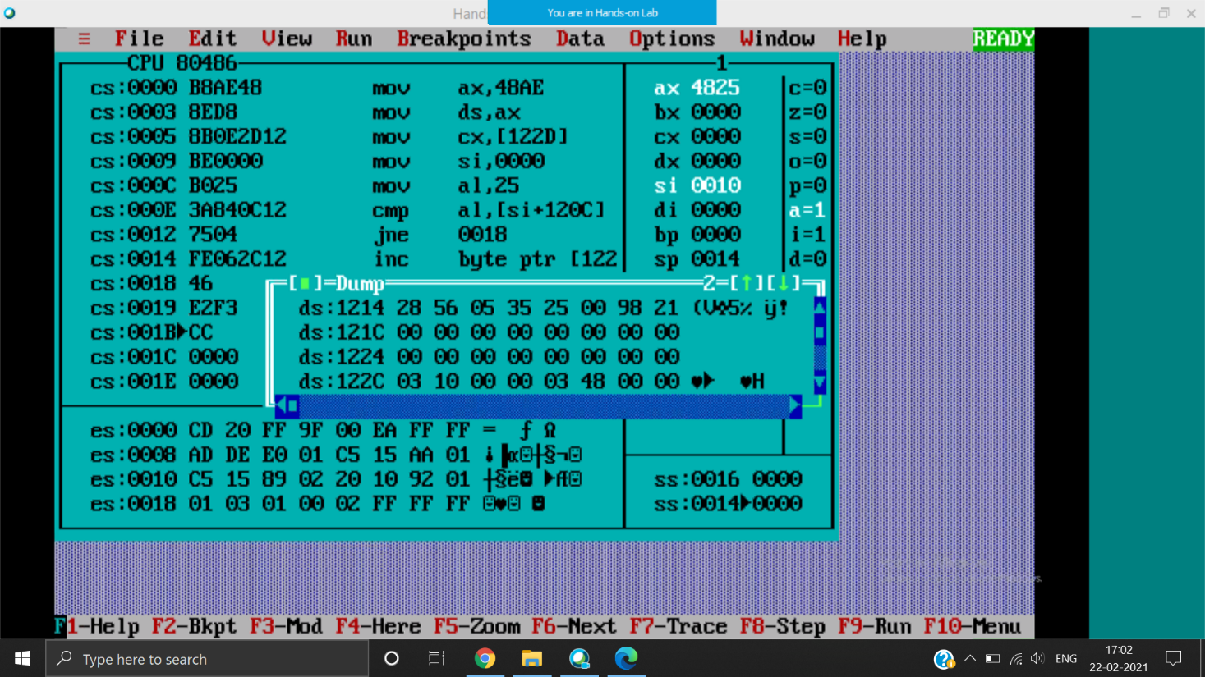

Output at 122C ie 3 times 25H occurs in ARRAY

P3: Write a program to exchange two data blocks of length 10-bytes stored in memory starting from 1200H and 1220H respectively.

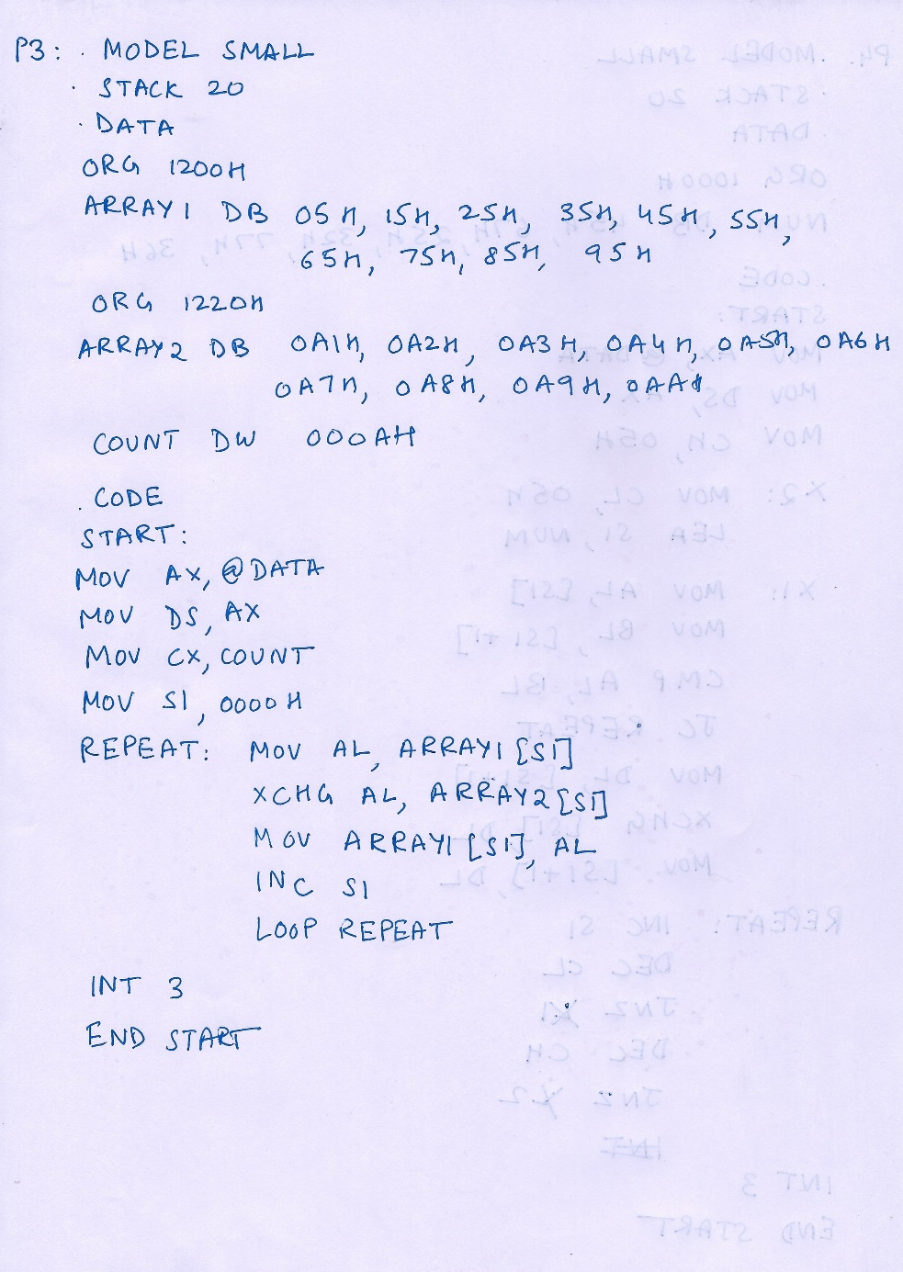

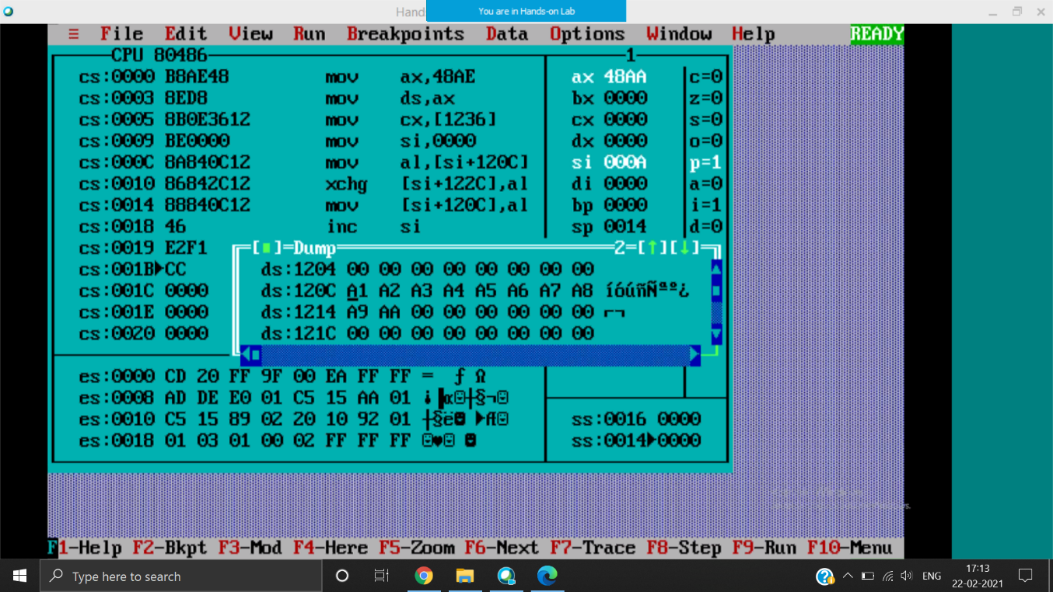 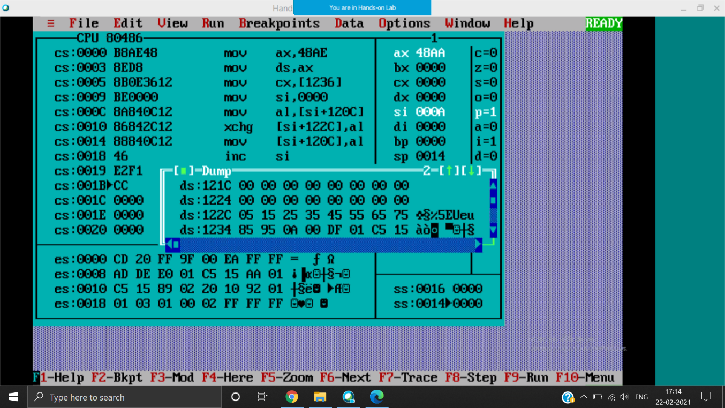

DS:120C

Values interchanged at 120C and 122C

P4: Write a program to arrange the given array of 8-bit binary numbers stored in the memory in ascending order. NUM DB 95H, 85H, 75H, 65H, 55H, 45H, 35H, 25H

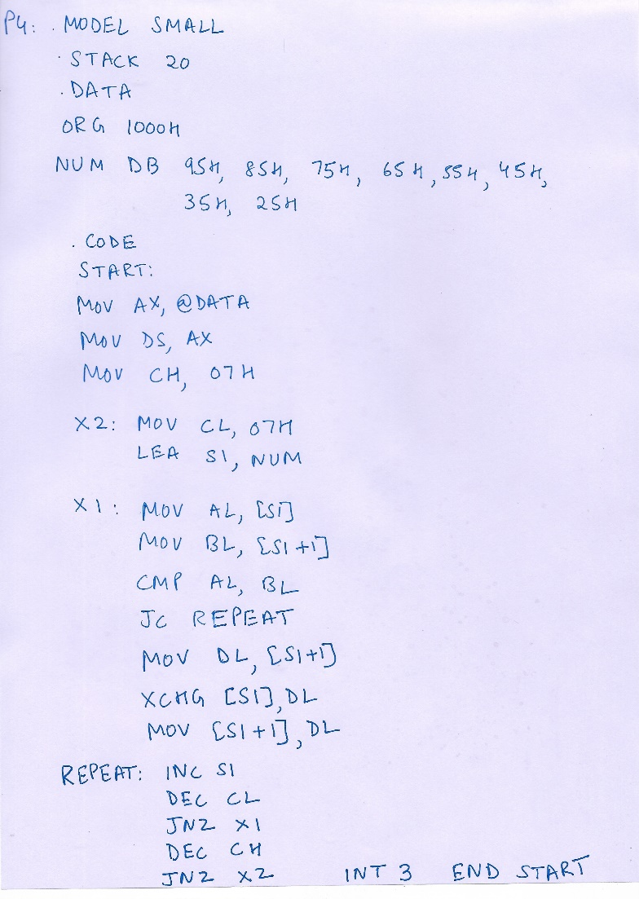

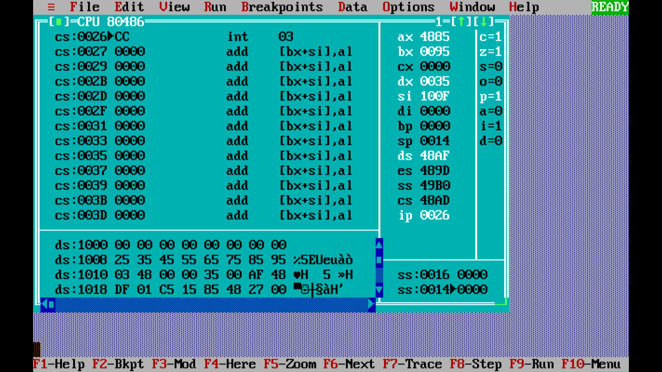

DS:1000H

Output at 1008H, numbers arranged in ascending order